**NETWORK**



**TOPOLOGY**



**Topology of a network is the geometrical representation of the relationship of all the links connecting the devices or nodes.**

**Six types of topology.**

* + **BUS**
  + **RING**
  + **STAR**
  + **MESH**
  + **TREE**
  + **HYBRID**

**BUS TOPOLOGY**

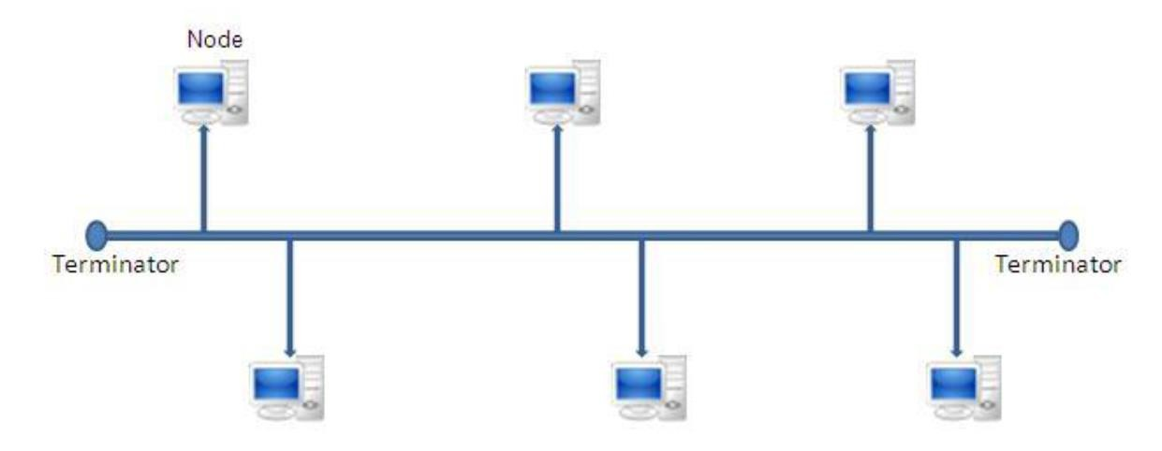



###### Advantages:

1. **It is easy to set-up and expand the bus network.**

###### Requires less cable length compared to other network.

1. **Bus topology costs very less since only main cable line is required.**

###### Linear Bus network is mostly used in small networks.



Disadvantages:

1. **If a main cable is damaged then network will fail or be split into two networks.**
2. Difficult to identify the problem if the entire network shuts down ,since single communication channel is shared by the network.
3. **It is slow when more devices are added into the network. More network traffic slows down the bus speed. Since only one device transmits at a time, all the other devices has to wait for the transmission time. This reduces the efficiency of the network.**

**RING TOPOLOGY**

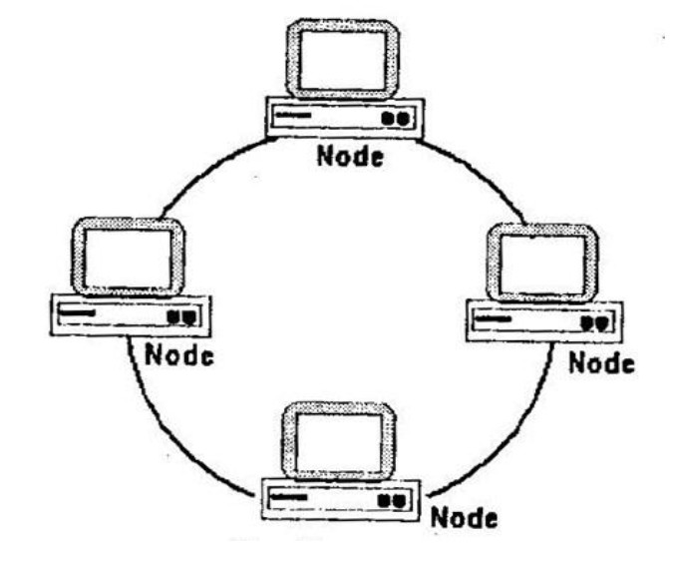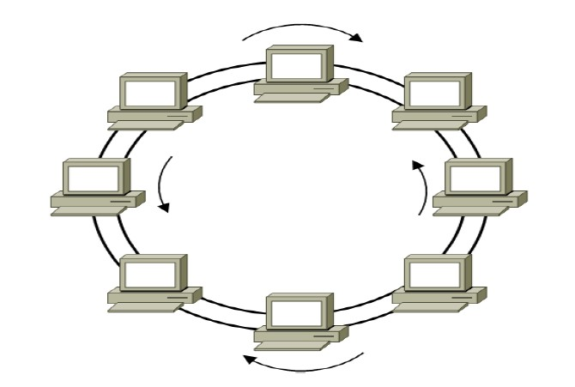

**SINGLE RING DUAL RING**



**ADVANTAGES:**

* + **It is easier to identify and isolate the fault in the network.**
  + **Data transfer is fast and without a bottle neck. It is relatively simple.**
  + **Adding additional nodes has very little impact on bandwidth.**
  + **It prevents network collisions .**

**DISADVANTAGES**

* **Each packet of data must pass through all the computers between source and destination.**
* **If a workstation or port goes down, the entire network gets affected.**
* **Network is highly dependent on the wire which connects different components.**
* **Network cards are expensive as compared to Ethernet cards and hubs.**

# STAR TOPOLOGY

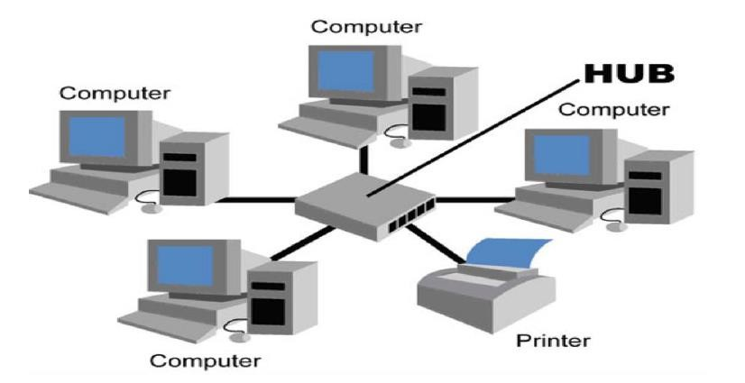



ADVANTAGES:

* **Performance of the network is dependent on the capacity of central hub.**
* **Easy to connect new nodes or devices. In star topology new nodes can be added easily without affecting rest of the network. Similarly components can also be removed easily.**
* **Monitoring the network is simple ,since it is a Centralized management.**
* **Failure of one node or link doesn’t affect the rest of network. At the same time its easy to detect the failure and troubleshoot it.**



**DISADVANTAGES:**

* **The entire network collapses if the central hub fails.**
* **The use of hub ,router or switches increases the establishment cost of network.**

# MESH TOPOLOGY

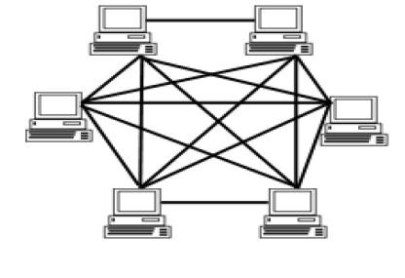



ADVANTAGES:

* + **Data can be transmitted from different devices simultaneously. This topology can withstand high traffic.**
  + Even if one of the components fails there is always an alternative present. So data transfer doesn’t get affected.
  + **Expansion and modification in topology can be done without disrupting other nodes.**
  + There is no traffic congestion problem, since multiple paths exits between the source and destination.



**DISADVANTAGES:**

* OVERALL COST OF THIS NETWORK IS WAY TOO HIGH AS COMPARED TO OTHER NETWORK TOPOLOGIES.
* **SET-UP AND MAINTENANCE OF THIS TOPOLOGY IS VERY DIFFICULT. EVEN ADMINISTRATION OF THE NETWORK IS TOUGH.**

# TREE TOPOLOGY

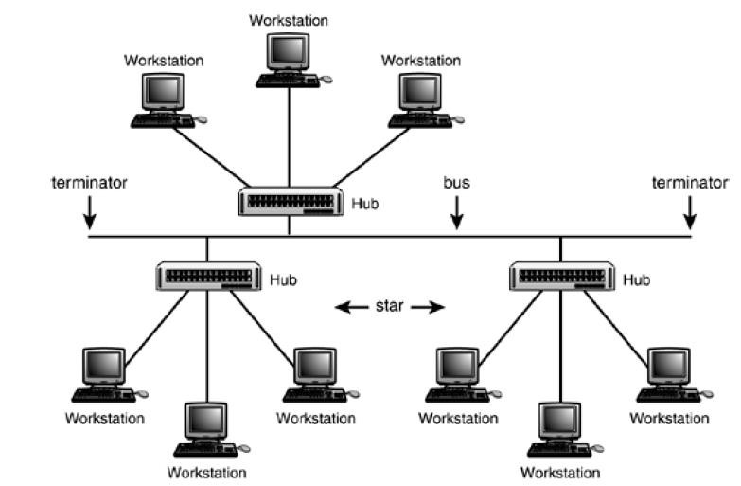

**ADVANTAGES:**

* + **It is an extension of Star and bus Topologies, so in networks where these topologies can't be implemented individually for reasons related to scalability, tree topology is the best alternative.**
  + **Expansion of Network is possible and easy.**
  + **The whole network can be divided into segments (star networks), which can be easily managed and maintained.**
  + **Error detection and correction is easy.**
  + **Each segment is provided with dedicated point-to-point wiring to the**

**central hub.**

* + **If one segment is damaged, other segments are not affected.**



DISADVANTAGES:

* **Because of its basic structure, tree topology, relies heavily on the main**

bus cable, if it breaks whole network is crippled.

* **As more and more nodes and segments are added, the maintenance becomes difficult.**

# HYBRID TOPOLOGY

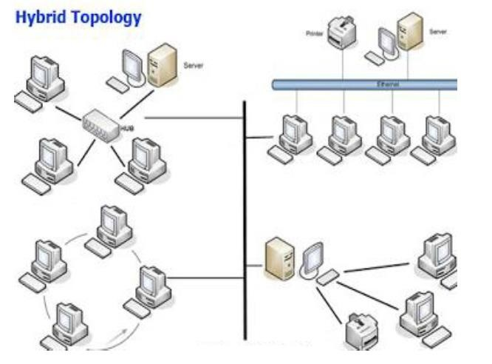



ADVANTAGES:

* **Reliable as Error detecting and trouble shooting is easy.**
* **Effective as it is easy to increase the size of network by adding new**

components, without disturbing existing architecture.

* **Scalable as size can be increased easily.**
* **Flexible as many topologies are connected together.**

DISADVANTAGES:

* **Complexity in the design of network.**
* **Implementation of the network is higher.**